PIARCS offers revolutionary solutions to peak oil, peak phosphorus and water pollution. In the near term, PIARCS’ novel bioreactor designs will enable algae-based biodiesel production prices under $ 92/barrel. Leveraging the founder’s interdisciplinary IP, PIARCS primarily conducts R&D and generates revenue through licensing. PIARCS was formed as a Delaware Public Benefit Corporation to promote environmental sustainability and is now seeking investment partners aligned with this public purpose.

Business PLan

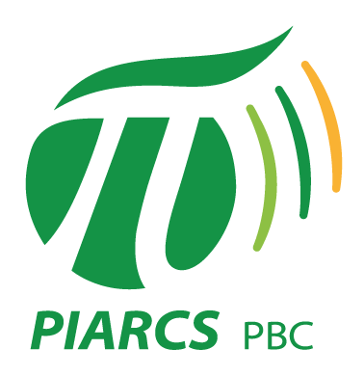

Table of Contents

**Executive Summary**

**Section 1: PIARCS, PBC** 1

**A - Overview of PIARCS, PBC** 1

**B – Business strategy: Broad licensing of PIARCS’ enabling IP** 2

**C – Algal biomass and biofuel: Market analysis** 3

a) State of the art and current limitations 3

b) PIARCS’ solutions 4

c) PIARCS’s already mature IP 5

**D – High loading phosphorus recovery & complete phosphorus removal: Market analysis** 6

a) State of the art and competition 6

b) PIARCS’ solutions 7

c) PIARCS’s already mature IP 9

**E – Market potential and expansion strategy** 10

**F – Timeline of deliverables and early income projections** 13

**G – PIARCS as a robust investment** 14

**Section 2: Management and operations** 15

**A – Business team (in progress) and location** 15

**B – Source and use of funds** 16

**C – PIARCS’ licensing fees and break-even analysis** 18

**D – Projected revenues** 19

**Section 3: Dividends, Risk, Valuation, Investment rounds and Corporate structure** 21

**A – Proposed dividend returns structure** 21

a) Some key definitions 21

b) Dividends on Series A Preferred Stock 22

c) Dividends on Common Stocks: a slow and conditional accrual of dividends 24

d) PIARCS’ dividend projections 25

**B – Risks and mitigating factors** 26

**C – Risk mitigation in terms of probabilities** 27

**D – Valuation (seed funding stage)** 28

**E – Planned investment rounds** 30

**F – PIARCS’ corporate structure and taxation** 30

**Section 4: Appendix and Supporting Documents** 31

**A – PIARCS’ founder CV** 31

**B – PIARCS’ legal and official documents available upon request** 31

**C – Guidelines to implement dividend projections** 32

**D – TERM SHEET (modified September 23rd 2014)** 34

Delaware Corporation founded in March, 2014

R&D in Algal biomass/biofuel & Water management

Investment sought: seed funding of $500,000 for 6-9 months R&D

Year 1 operation: delivery of all critical R&D milestones (Boulder, CO)

Equity funding campaign: <https://www.returnonchange.com/piarcspbc>

Third party due-diligence by: Crowdcheck Reports (thomasofficer@crowdcheck.com)

**PIARCS primarily conducts R&D and generates revenue through broadly licensing its IP**.

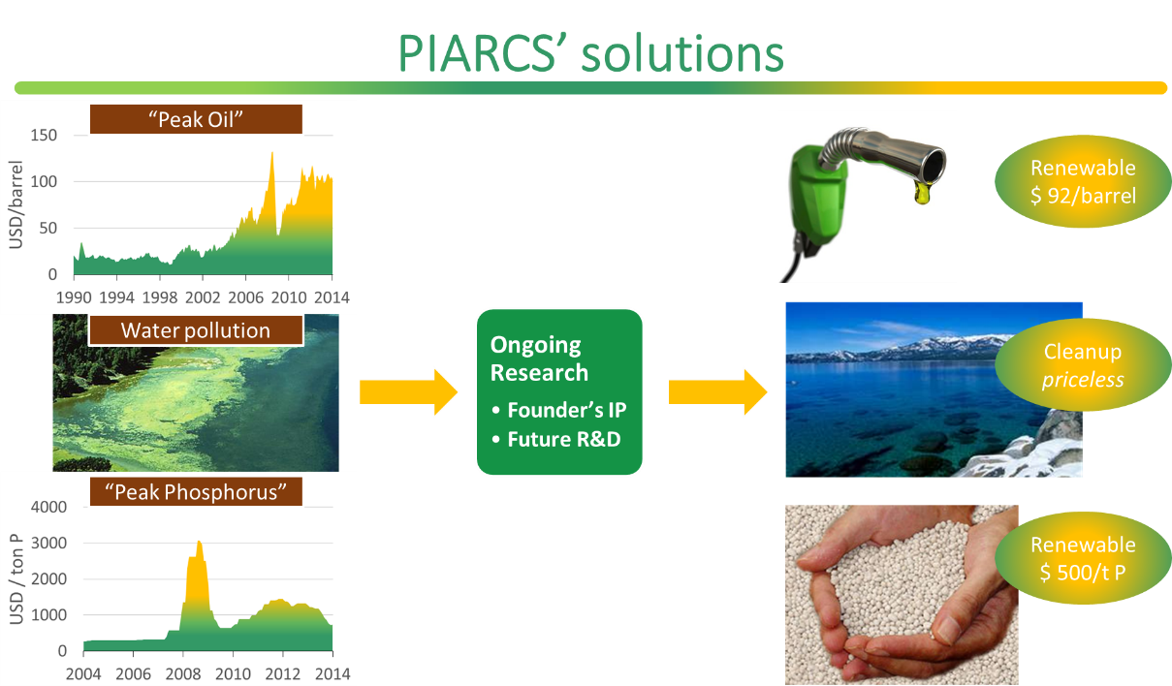

Leveraging the founder’s proprietary IP, PIARCS’ R&D in two unrelated areas aims to achieve the following revolutionary solutions:

* **Novel algal bioreactor designs. Targets algae-based biodiesel production prices under $92/barrel and an inexpensive biomass feedstock**. PIARCS’ Chemical Engineering approach aims to enable high algal efficiency, as opposed to current designs which select for high speed. The resulting biomass production model allows for the continuous production of lipids (biofuel) as well as nutrients-free effluents.
* **Novel bacterial phosphorus sequestration method. Affords complete removal of phosphate from wastewater and a source of renewable phosphorus fertilizer**. The dried biomass phosphorus (P) content (9-17%) compares with the 11-16% found in rock-phosphates, which currently provide a primary yet limited global fertilizer resource. The final dissolved inorganic phosphate levels (< 30 µg P/L) meet upcoming EPA standards, which are driving costly upgrades in wastewater treatment plants nationwide.
* **Process integration of these technologies affords wastewater cleanup**.



* **Limited competition**

The 2005-2008 Algal Biomass hype has largely failed to deliver scalable solutions to supply transportation fuel.

* **Mature IP**

**PCT application submitted Oct. 14th 2014 (Marsh Fischman Breyfogle LLP)**,based on founder’s independent work and three peer-reviewed publications.

* **Unimpeded IP**

Distinct approaches to algal lipid production and biomass productivity maximization.



* **Limited competition**

Current wastewater upgrade plans aim to implement the competing Ostara Pearl (2012) and Siemens Water Tech. CoMagTM (2013) systems to meet upcoming EPA phosphorus standards. In addition to higher performance, PIARCS’ technology is on the order of 1/10th the cost to implement.

* **Mature IP**

**Provisional Patent application filed April 7th 2014 (Klarquist Sparkman, LLP)**, based on founder’s independent and unpublished work.

* **Unimpeded IP**

Patented biological sequestration methods use unrelated approaches.

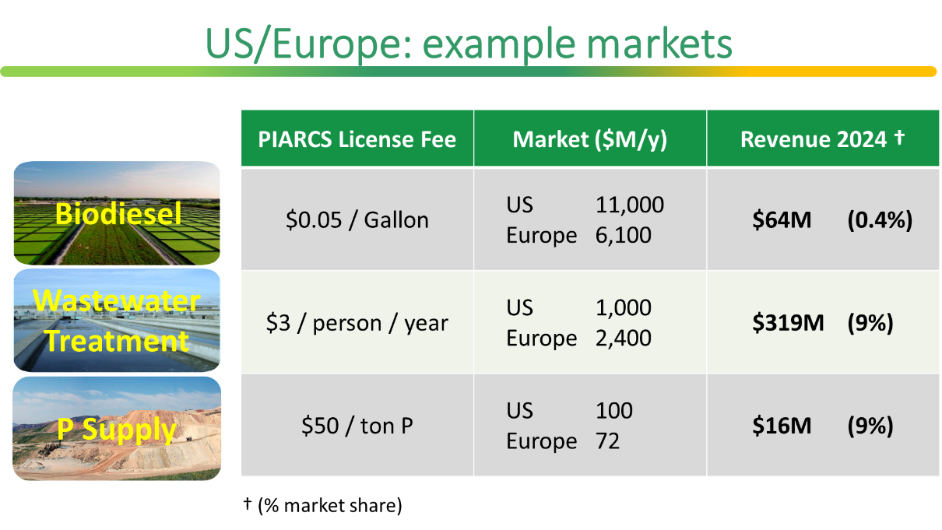

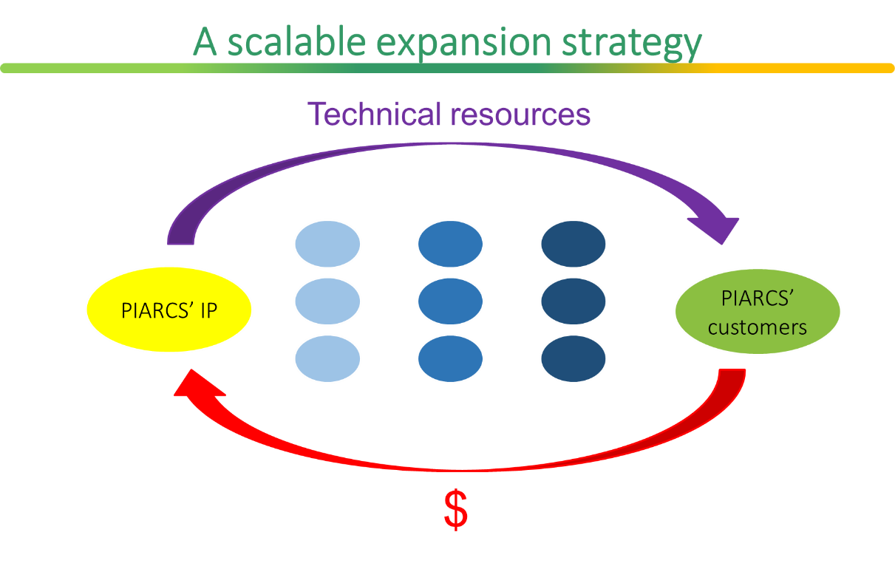

As a Public Benefit Corporation, PIARCS aims to catalyze the advent of a sustainable commodity industry:

* Low-cost licensing to end-users only (algal biomass producers and wastewater treatment plants),
* Continuous development of technical resources for licensees at no additional cost,
* Strategic partnerships with manufacturers and CleanTech companies,
* Sponsoring a wide array of Public Benefit projects (education, energy efficiency, conservation and environmental cleanup).



* **Capital efficiency**: the proposed lab structure to validate the far-reaching implications of PIARCS’ IP is inherently efficient, since it only requires a small well-led R&D team and minimal funding: $0.2M lab setup cost, $0.3M operating cost for Year 1, and a $2M operating cost for Year 2-3 (pilot scale validations), after which point PIARCS should ensure sustained revenues from licensing and partnerships.
* **Risk mitigation**: the dual R&D focus provides risk mitigation for the investors, as well as a dual revenue stream from a fixed setup cost.
* **Key risks are taken early**:The main IP milestones are to be reached within the first 6-9 months of Year 1 R&D, with key patents submitted and validated.
* **Near-term markets**: the highly mature phosphorous IP alone provides a robust near-term revenue stream.



The contractual dividend structure, provided as an amendment to PIARCS’ Certificate of Incorporation, was designed to conciliate:

* PIARCS’ priority to achieve rapid Return on Investment for seed investors
* As well as a lightening of the dividend financial burden as the company expands (from 25% of the annual net income Year 4 to below 5% from Year 7 on).

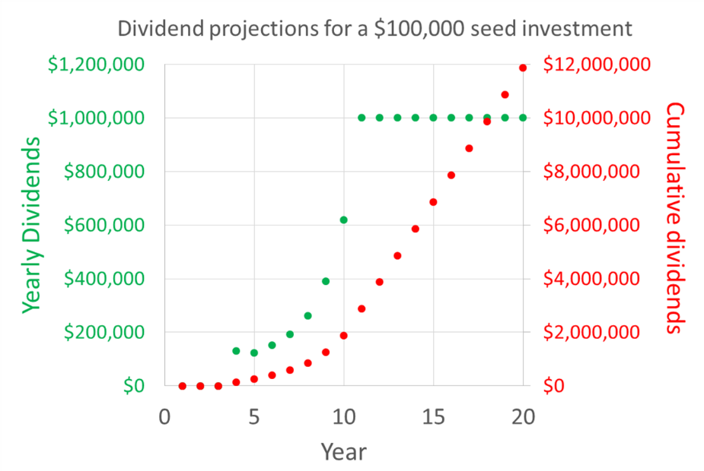



Alexandra Holland, PhD, Founder and CEO

* Interdisciplinary training (Chemical Engineering and Microbiology)
* Pedagogical experience
* 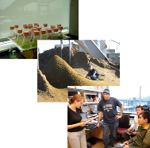International and multi-disciplinary scientific ties

X, PhD (currently employed elsewhere)

* Algal culture optimization
* Bacterial production processes (team leader)

Joe Dragavon, PhD

* Analytical Chemistry
* Co-author on two publications

I look forward to discussing this initiative further with you. Please contact me at:

(562) 310-7570

holland@piarcs.org

Delaware Corporation founded in March, 2014

R&D in Algal biomass/biofuel & Water management

Investment sought: seed funding of $500,000 for 6-9 months R&D

R&D activity in Boulder, CO

# **Section 1: PIARCS, PBC**

## **A - Overview of PIARCS, PBC**

**PIARCS primarily conducts R&D and generates revenue through licensing**. Leveraging the founder’s proprietary IP, which results from a 3-year personally funded suite of post-doctoral experiences as a guest in various international laboratories, PIARCS offers revolutionary IP solutions to peak oil, peak phosphorus, water pollution and drinking water shortages.

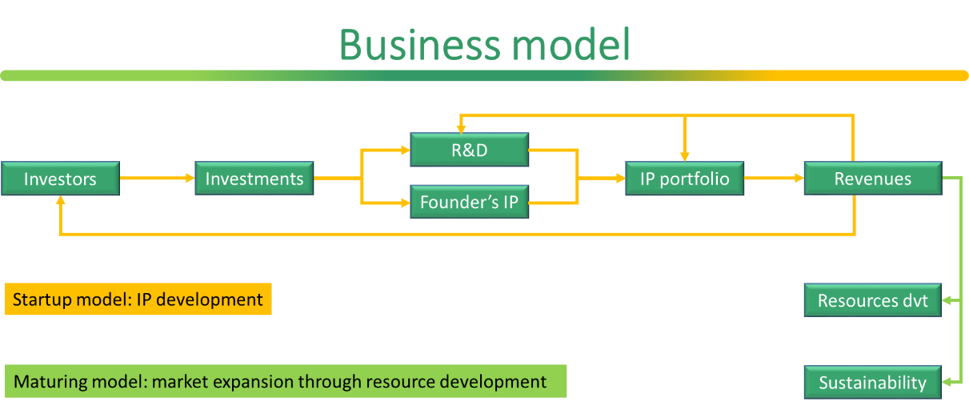

**PIARCS’ near term customer base comprises**:

* companies undertaking large-scale algal biomass/biofuel production
* wastewater cleanup facilities (stringent EPA standards effective by 2022-2031)
* fertilizer suppliers

By broadly licensing its IP portfolio, and developing technical resources at no additional cost, PIARCS enables the parallel implementation of these sustainable technologies by a multitude of entrepreneurs worldwide. In addition, PIARCS intends to establish mutually beneficial interactions with the CleanTech industry by highlighting the performance of complementary technologies (wind turbines, solar cells…) and licensing its IP to existing integrated solution providers (wastewater treatment…).

**PIARCS was founded as a Delaware Public Benefit Corporation** in March 2014 to promote environmental sustainability. PIARCS seeks to attract global vision investors to provide the seed funding of $ 500,000 M/6-9 months R&D, with a preferred minority equity investment structure involving annual dividend returns once the company enters its licensing phase.

## **B – Business strategy: Broad licensing of PIARCS’ enabling IP**

PIARCS offers revolutionary solutions to peak oil, peak phosphorus and water pollution. In the near term, PIARCS’ two independent IP areas will validate:

* **Novel bioreactor designs: algae-based biodiesel prices under $ 3/gallon and an inexpensive biomass feedstock**. The productivity maximization strategy under high outdoor light stems from the founder’s Chemical Engineering approach, and allows to establish a simple descriptive biomass production model – lacking in the field to-date. Such controversial model (P=Φ·I) allows for the continuous production of lipids (biofuel) as well as nutrients-free effluents.
* **1-step biological method: high loading and complete removal of phosphate from wastewater**. The easily extractable phosphorous (P) content from the dried biomass (9-17%) compares with the 11-16% P in commercial phosphate rocks (BPL 60-80), which currently provide a primary yet limited global fertilizer resource. The final dissolved inorganic phosphate levels (< 30 µg P/L) meet upcoming stringent phosphorus regulations.

In the medium term, process integration of these two R&D foci will lead to the **production of drinking quality water from wastewater** or polluted water streams.



**PIARCS licensing rates will be designed to represent on the order of 5% of the commodity final sale price at a reasonable market value** (e. g. $92/barrel for algal biodiesel and $500/ton P, which are lower than current market values). These rates (e. g. $0.05/gal biodiesel and $50 ton P) will be kept constant throughout the improvement of the technology resulting from the licensing revenues, as well as solely proportional to actual commodity production.

## **C – Algal biomass and biofuel: Market analysis**

### State of the art and current limitations

Algal biomass productivities are currently on the order of 20 gDW m-2 d-1 (yearly average, DW: dry weight) in Southern US latitudes. These solar intensities should afford productivities on the order of 100 gDW m-2 d-1 under nutrient replete conditions, according to the biomass yields measured experimentally by Dr. Alexandra Holland.

In addition, algal production facilities lack a reliable growth model to predict algal biomass production. The current consensus in the field is to use specific growth rate µ to describe biomass production, as is common in Biology. In the absence of a reliable growth model, algae are grown in excess nutrients leading to waste of an expensive feedstock as well as the production of a contaminated effluent. As a stark contrast, Dr. Holland proposes to use a yield-based model, derived from a Chemical Engineering material and energy balance (Holland et al. 2011 Biotechnology Journal. 6:584).

While algal biomass yields presently prove sub-optimal, algal lipid yields are correspondingly lower since they furthermore rely on a discontinuous process, in which algae are first grown in nitrogen (N) excess, then transferred to a N-depleted environment. Algal lipid productivities are reportedly on the order of 830 gal acre-1 y-1 (Davis et al. 2011 Applied Energy 88 3524), while PIARCS’ proposed continuous process should achieve ~ 7500 gal acre-1 y-1 at comparable latitudes.

Continuous lipid production has been shown with algae grown on sugars (heterotrophic growth). This model is deemed not sustainable since the process relies on crop sugar production to supply its energy source. This intermediate step constrains the overall system efficiency to be lower than crop yields, which are lower than autotrophic algae (grown with light as sole energy source).

As a consequence of using Biology models based on growth rates µ, algal strains have been selected for high µ (“speed”), which are measured under light excess. Dr. Alexandra Holland’s controversial approach proposes to select strains for high growth yields Φ under light limitation (“efficiency”). Importantly, just as speed and efficiency are not correlated in natural systems, µ and Φ are not correlated (Holland’s published experimental results, and theoretical derivation by Wong et al. 2009 Biotechol and Bioengineering. 102:73).

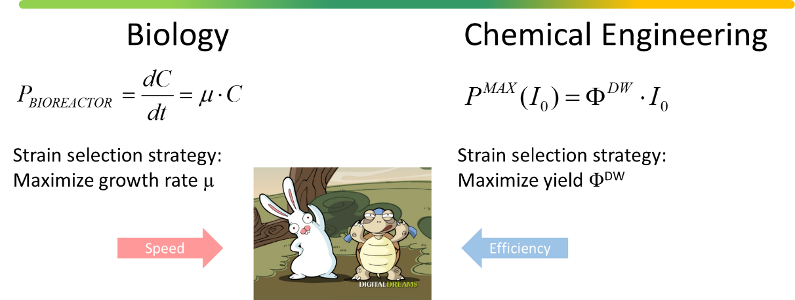

However, the Chemical Engineering yield-based model only holds under low light, which corresponds to low photon flux per cell. Indeed, algal physiologists have widely documented that yield decreases with increasing irradiance, at levels much below direct sunlight. So how can the Chemical Engineering model hold under outdoor or high intensity settings?

### PIARCS’ solutions

Dr. Holland proposes an interdisciplinary approach to ensure low photon flux per cell under elevated irradiances such as in outdoor ponds. This condition is essential to not only ensure the validity of the simple Φ-based model, it also ensures maximum biomass productivities. Indeed, under low photon flux per cell, each incident photon is absorbed by the algal particle and metabolized to produce biomass.

The “low photon flux per cell” (LPFC) condition relies on the algal physiology understanding of the kinetics of energy transfer from photon energy to energy-rich biomass. The satisfaction of this LPFC condition in a bioreactor relies on the Engineering design of suitable flow patterns, which is the object of a PIARCS’ WO patent currently in progress with Ross Breyfogle at Marsh Fischman Breyfogle LLP.

PIARCS’ IP delivers projected lipid productivities on the order of 7,500 gal acre-1 y-1 for average yearly irradiances of 390 µE m-2 s-1 in such as in Southern CA (for 25% harvestable lipids).

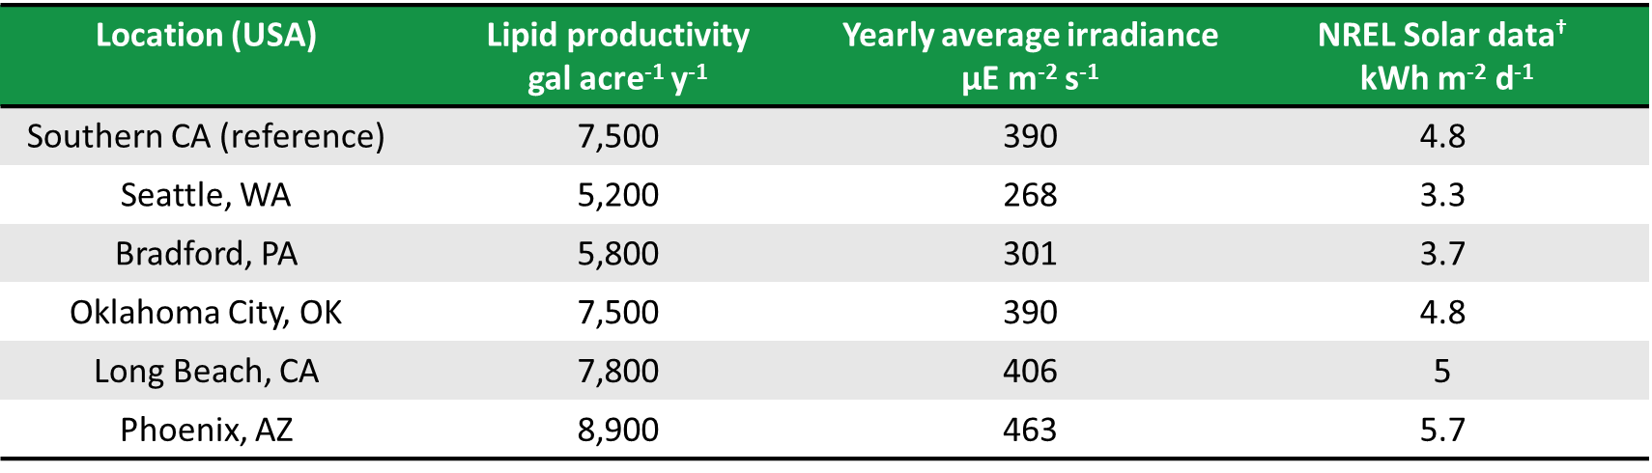

†http://www.nrel.gov/docs/legosti/old/5607.pdf

**Table 1**. Projected algal biofuel (lipids) productivities

Such productivities would satisfy US transportation needs by covering 29 million acres (1.55 % mainland US).

Biodiesel prices are a function of nutrients management. Based on the NREL financial analysis by Davis et al. 2011 (Applied Energy issue 88; pp. 3524–3531), and assuming 50% scalable operating costs and 10% IRR over 20-year, the following prices were calculated (Figure 1).

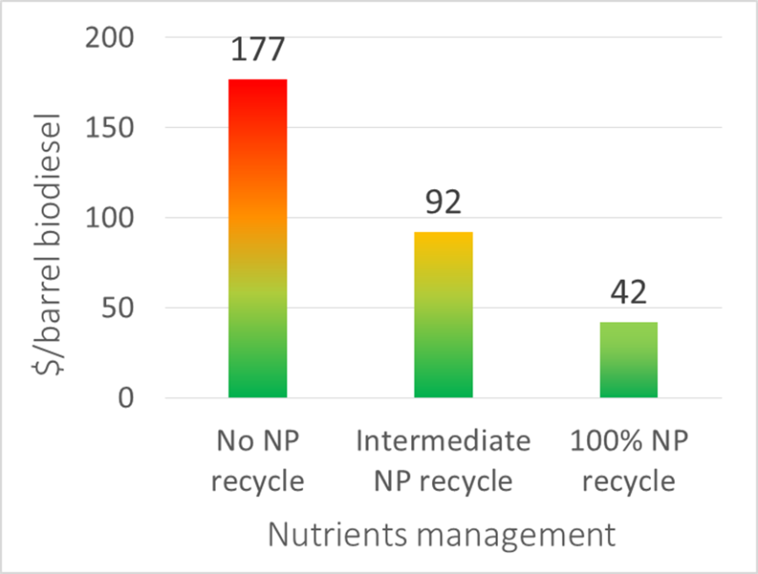

**Figure 1**. Projected biodiesel production prices as a function of nutrients recycling for a reference irradiance of 4.8 kWh m-2 d-1 (yearly average, Southern half of the US). “Intermediate NP” recycling corresponds to 37% phosphorus and 68% nitrogen recycled.

### PIARCS’s already mature IP

Prior to founding PIARCS, Dr. Alexandra Holland has laid the scientific foundations for the proposed R&D in the following publications:

* Holland AD and J Dragavon. Algal Reactor Design Based on Comprehensive Modeling of Light and Mixing. *Algal Biorefineries*, vol.1. Springer Publishing, New York, USA. (**October 15 2013**).
* Holland AD and D Wheeler. Methods for Estimating Intrinsic Autotrophic Biomass Yield and Productivity in Algae: Modeling Spectrum and Mixing-Rate Dependence. *Biotechnology Journal.* **2011** 6:584-599.
* Holland AD, Dragavon J and DC Sigee. Methods for Estimating Intrinsic Autotrophic Biomass Yield and Productivity in Algae: Emphasis on Experimental Methods for Strain Selection. *Biotechnology Journal*. **2011** 6:572-583

This controversial approach enjoys as a result a very favorable patent landscape. Indeed, thorough patent searches have retrieved unrelated approaches to algal lipid production and biomass productivity maximization.

**A PCT patent application has been filed on October 14th 2014 with Ross Breyfogle at Marsh Fischman Breyfogle LLP**, and is assigned to PIARCS, PBC (Alexandra Holland is the sole inventor). This application will cover the algal bioreactor flow pattern design principles enabling a yield-based description of algal biomass production. In-turn, this yield based model allows for:

* maximization of biomass productivity under high light
* continuous lipid production
* production of nutrients-free effluents

## **D – High loading phosphorus recovery & complete phosphorus removal: Market analysis**

### State of the art and competition

Phosphorus (P) is an essential crop nutrient for which there is no substitute. While all farmers need access to rock-based phosphorus fertilizers, just 5 countries control around 90% of the world’s remaining phosphate rock reserves, including China, the US and Morocco. Current high-grade reserves will likely be depleted within 50-100 yrs.

In parallel, municipal, agricultural and animal husbandry runoffs are leading to an accumulation of P in natural ecosystems. While phosphates are not toxic to humans, low P concentration alone can support algal growth in the presence of light (cyanobacteria are able to fix N from the atmosphere). This in-turn leads to eutrophication of lakes and streams. The EPA is addressing this issue by enforcing nationwide numeric criteria for nitrogen and phosphorus levels in wastewater effluents: http://cfpub.epa.gov/wqsits/nnc-development/

This dual challenge highlights the importance of treating wastewater for both high loading P recovery (i.e. as a concentrated material) and complete P removal. Common methods can perform one or the other. The chemical methods which perform both preclude P re-extraction as a cost effective alternative, and lead to high volumes of waste.

High loading P recovery methods:

* Biological Nutrient Removal (BNR) consists of a sequence of biological reactors (aerobic, anaerobic cycling) which involve naturally occurring bacterial populations. These reactors accumulate P to high loading, but the final P levels are often unpredictable and fairly high (0.2 – 1 mg/L).
* Struvite production uses very high concentration influents and produces an intermediate P concentration effluent (~15 mg P/L).

P removal methods:

* Chemical precipitation by trivalent metal salt addition (aluminum sulfate, ferric chloride, ferrous and ferric sulfates) or lime. Precipitation requires a chemical excess, which adds bulk to the sludge, and incurs significant O&M costs. The precipitates, which allow to reach P levels < 0.1 mg P/L in the effluent, preclude cost-effective recovery of the bound P (acid/base treatment).
* The 2013 Siemens Water Tech. CoMagTM system uses magnetite to separate P and other impurities from wastewater, with recycling of magnetite after chemical treatment. This system is highly effective to polish low P concentration influents to very low levels, but cannot easily handle P-rich influents.
* Algae can be used to remove P to undetectable levels as they incorporate the nutrient into their biomass. Effective P recovery is rendered difficult since the P is assimilated as a variety of metabolic products (nucleic acids, phospholipids …), and the overall weight fractions are low (0.5-2% P on a dry weight basis). This process also needs light, which is very costly to implement for the high volumes treated daily by wastewater treatment facilities.
* Imbrium Systems Inc. sorptive medium is a filtration-based system which removes P from wastewater to levels < 0.1 mg/L. However, the breakthrough bed volume is on the order of 500 BV, such that for every 500 gallons of water treated, 1 gallon of sorptive medium needs to be used – and discarded, incurring significant amounts of solid waste.

BNR and chemical precipitation are the most commonly implemented P removal methods in wastewater treatment plants. Both the Siemens CoMag (2013) and Ostara struvite (2011) systems, while expensive, are meeting early success, which bodes well for PIARCS’ technology.

### PIARCS’ solutions

PIARCS proposes to use strains from a non-traditional genus to remove P from wastewater. This strain affords both high loading P recovery and reliable complete P removal from wastewater.

Either as conditioned wild-type or engineered strains, Dr. Alexandra Holland has found that PIARCS’ proprietary strain accumulates phosphate from high concentration environments (60-120 mg P/L) as polyphosphate (10,200 -23,000 nmol P-PolyP/mg protein or 8.5-17% P as polyphosphate in the final dried biomass). In addition, phosphate is removed to concentrations < 0.03 mg P/L (detection limit, maybe even lower) in a biomass which does not leach P.

Polyphosphates (as 8.5-17% P in the final dried biomass) can easily be converted back to phosphate using enzymatic treatment and further processed into high grade fertilizer. This contrasts with the more difficult P extraction from commercial rock phosphates (11-16% P), which currently provide a primary yet limited global fertilizer resource.

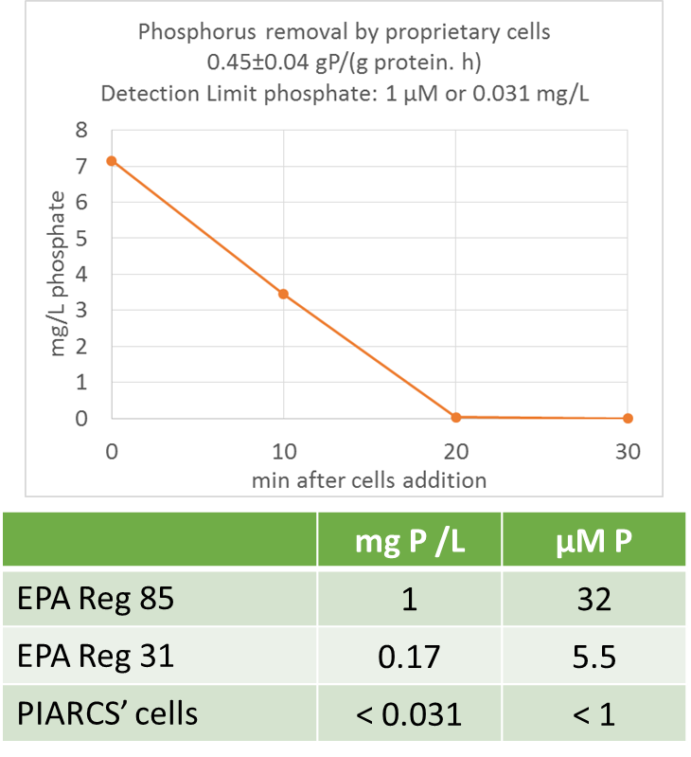

**Figure 2. Phosphate removal** (triplicate samples). State of Colorado EPA Reg 85 comes into effect 2022, and EPA Reg 31 in 2031. PIARCS’ proprietary IP allows to easily meet and exceed the EPA standards coming into effect in the next 8-17 years.

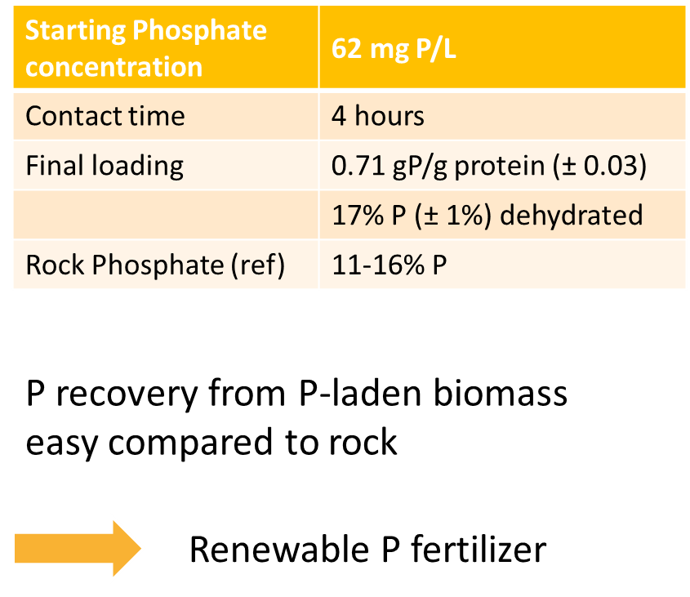

**Figure 3. Phosphorus accumulation** (triplicate samples). Final loading of 0.71 gram Phosphorus per gram of bacterial protein, which corresponds to 17% on a dry weight basis. Enzymatic P extraction from biomass is much easier that chemical recovery from Rock Phosphate, and provides a convenient feedstock for renewable fertilizer production.

### PIARCS’s already mature IP

Dr. Holland’s discovery of the efficacy of PIARCS’ cells for phosphorus recovery and removal was achieved in various steps during her unpaid post-doctoral experiences. These results were not published until she filed the provisional patent “Methods of Phosphorus Sequestration Using (…)” on April 7, 2014, assigned to PIARCS, PBC. The provisional patent was drafted by Susan Graf at Klarquist Sparkman, LLP.

In addition to her groundbreaking P sequestration results with the non-pathogenic bacterium, Dr. Holland has complementary experience which will streamline the near-term application of this IP to wastewater treatment facilities. First, she has developed and optimized growth media for a bacterium as well as a series of microalgae:

* Holland AD, Rothfuss HM and ME Lidstrom. Development of a defined medium supporting rapid growth for *D. radiodurans* and analysis of metabolic capacities. Applied Microbiology and Biotechnology. **2006** 72 (5): 1074-82.
* Holland AD, Dragavon J and DC Sigee. Methods for estimating intrinsic autotrophic biomass yield and productivity in algae: Emphasis on experimental methods for strain selection. *Biotechnology Journal*. **2011** 6:572-583

Growth medium development will be key to assess the suitability for PIARCS’ strains to grow on wastewater and perform P sequestration. The metabolic potential and industrial versatility of non-pathogenic bacteria are currently being exploited successfully by a French company in the area of nutraceuticals and green chemistry.

Second, during her PhD with renowned Microbiology Professor Mary Lidstrom (University of Washington, Seattle, WA) as well as during her post-doctoral experiences, Dr. Holland has developed an extensive experience in genetic engineering of bacteria.

Third, her undergraduate experience in Jay Keasling’s lab working on Enhanced Biological Phosphorus Removal gave her great perspective about the prospects and limitations in this field, as well as key professional connections.

The unexpected P sequestration capacity from PIARCS’ proprietary strains enjoys a very favorable patent landscape. Indeed, patent searches have retrieved solely unrelated approaches to biological P accumulation. Indeed, EBPR relies on bacterial populations, and genetic engineering approaches in *E. coli* involve different sets of genes.

## **E – Market potential and expansion strategy**

PIARCS’ licensing prices are designed to promote broad implementation of the technology. The fee is designed to be on the order of 2-10% of the final commodity retail value, whether the commodity is algal biomass, biodiesel, dried P-laden bacterial biomass or clean water. The range given accounts for recent commodity price variability. The fee itself will be the same for all customers, with adjustments for emerging economies and inflation, fixed in time and proportional to actual yearly commodity production. This model intends to create an equally favorable environment for large corporations, start-ups or farmers transitioning to the implementation of PIARCS’ IP.

PIARCS’ US and European markets are given as examples below:

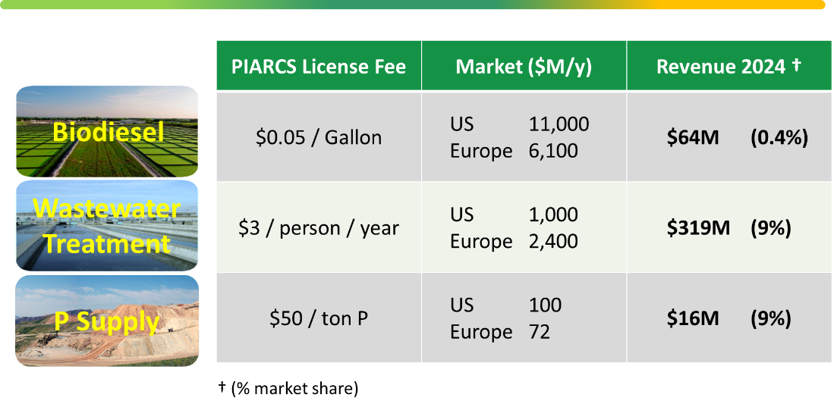

**Figure 4**. PIARCS’ revenue potential

Actual market penetration dynamics will depend on a successful expansion strategy based on industrial cooperation and public support.

PIARCS expects to reach 100% of the markets in the next 10-20 years for the following reasons:

* PIARCS consolidates R&D efforts and shares the benefits with all licensees. The annual licensing fee is proportional to production and constant.
* In-turn, as the industry expands more quickly thanks to these consolidated R&D efforts, this will allow to reach the critical mass needed to engage policy-making and large-scale infrastructure discussions at the government level. Indeed, the expansion dynamics of this emerging sustainable industry will quickly depend on a broader social and political context, which needs to be addressed collectively by the industry.
* PIARCS’ fee is low considering the technology resources made available for customers. These resources, which are constantly improving thanks to the annual licensing revenues, will allow to streamline implementation globally.
* PIARCS’ process integration focus will afford optimal process designs by highlighting the value of implementing complementary technologies (wind turbines, solar cells …). The indirect benefits for PIARCS would lie in the stimulation of a creative and diverse Cleantech industry, and the public image that the PBC strives for optimal designs benefiting society.
* PIARCS’ Public Benefit purpose will allow to devote significant funds to broadly promote social acceptance. Importantly, large-scale projects should involve discussion with impacted populations, and PIARCS will ensure that such process is respected by the developing industry. In addition, PIARCS will sponsor a wide array of projects in the areas of education, awareness, energy efficiency, conservation and environmental cleanup.
* A significant part of the licensing fees will be spent locally on such Public Benefit projects.

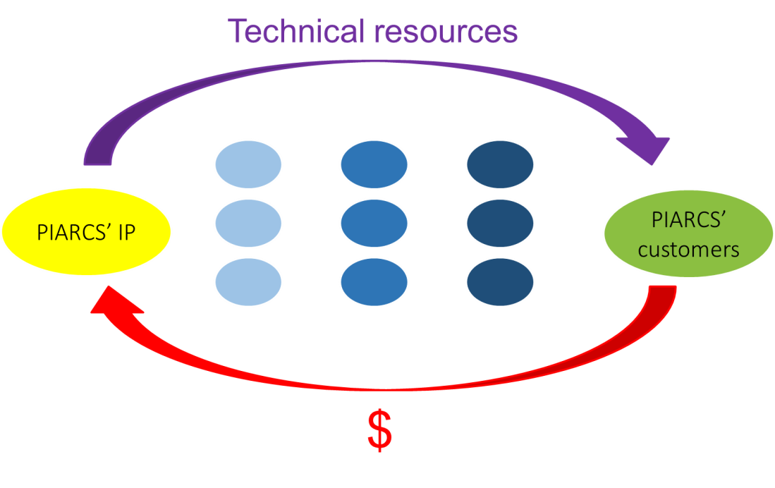

**Figure 5. PIARCS’ expansion strategy**

PIARCS’ success is tied to the expansion strategy described above, especially in the light of the recent failures encountered by the Wind industry in France. Indeed, as a stark contrast, despite a fantastic technology, the Wind industry been meeting tremendous adverse social pressure and financial setbacks:

* The developers are disregarding aesthetic landscape and landmark considerations when deciding upon implantation sites.
* The developers are attempting to bypass public discussion forums by lobbying laws at the state level which reduce public recourses, and by signing contracts directly with land-owners and local government authorities.
* Certain developers have chosen poor quality wind turbines which have short lifetimes and are left to degrade on-site, witch associated risk for the neighboring communities.
* Dismantling of the turbines is mandated after 20 years, and is the responsibility of the developers if the company still exists. If not, the financial responsibility is shifted to the leasing land-owner, and if the latter unable, to the neighboring communities.
* The neighboring communities do not get compensated for the visual/sound impairment resulting from the implantation of 20-50 150m-high turbines (500ft) in a 20 km radius, which typically incurs a 30% drop in property value.
* As a result of this process, Wind development in France has been met with tremendous resistance from the local populations, which has incurred significant cost for the Wind industry in the form of legal expenditures, construction setbacks or premature dismantling.
* At the state level, the promotion of Wind power currently disregards the engineering constraints of grid matching of an intermittent power source to a slow-response power such as nuclear power (>80% of French electricity). This results in the necessity to build matching gas turbines, thereby creating an unseen capital cost associated with Wind development.

Wind power, nevertheless, holds promise to provide long-term sustainable energy if appropriate measures are taken. For example:

* Include the neighboring communities to decide collectively on the implantation sites, size and height.
* Incentivize impacted communities with preferential electricity rates, funds to improve home insulation, and/or a basal income.
* Incentivize the broader community by offering a preferential electricity rate to reward scheduling flexibility – which allows to match intermittent wind power to a flexible demand and to bypass the requirement for associated gas turbines.
* Ensure long-term maintenance of the Wind infrastructures by developers much beyond 20 years.

**F – Timeline of deliverables and early income projections**

Once the critical R&D milestones have been reached in Year 1, PIARCS aims to partner with infrastructure providers and early adopters to reach full scale production by Year 4 for Phosphorous removal, and by Year 5 for Algal Biofuel production.

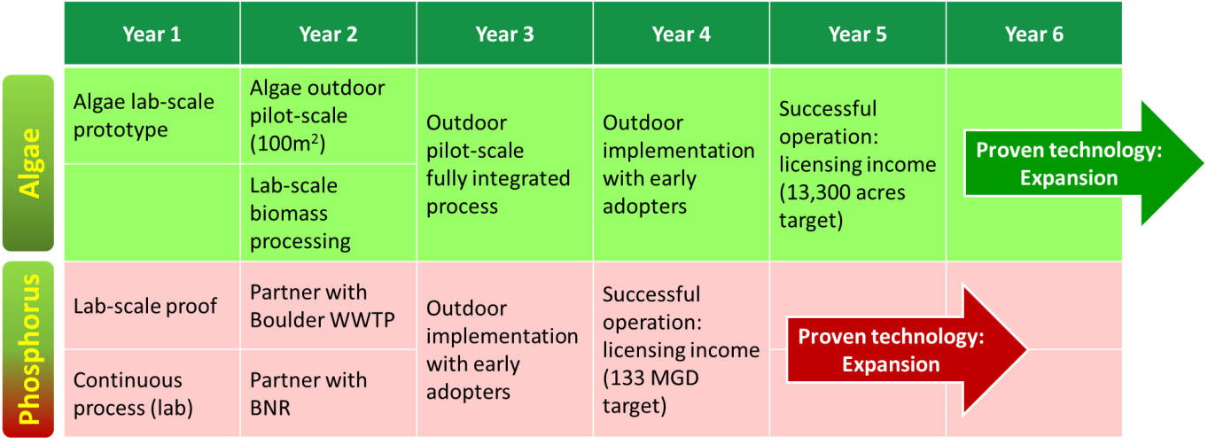

**Figure 6**. Timeline of deliverables

Based on algal lipid production, a Southern US algal lipid pond coverage of 13,200 acres by the end of Year 5 would allow licensing revenues of $2M per year. This would produce about 40 million gallons biodiesel per year, satisfying 0.018% of the US market, or 0.012 % of the US & Europe transportation fuel consumption (see **Fig. 5** for market sizes).

P removal using PIARCS’ license will be charged $ 37,500/MGD per year to wastewater treatment plants. MGD (million gallons per day) describe the plant treatment capacity. This fee is lower than the operating expenses associated with other P removal treatment methods (Ostara struvite production and CoMag).

The total US capacity is 26,150 MGD (2008), and would generate a PIARCS revenue of $ 1 billion per year. The Boulder, CO wastewater treatment plant capacity of 12.5 MGD would generate $ 470,000 per year, and the South Renton, WA facility of 133 MGD would generate $ 5.0 million per year. The Renton facility alone represents 0.5% of the US market, or 0.15% of the US & Europe markets (see **Fig. 5** for market sizes).

## **G – PIARCS as a robust investment**

PIARCS represents a robust near-to-far term investment thanks to the following strategic advantages:

* **Cooperative expansion strategy**: PIARCS’ strategic position aims to lead the emergence of a sustainable commodity industry by broadly providing R&D services. This will lead to highly mutually beneficial interactions with funding partners firms’ existing and future portfolio companies.
* **Capital efficiency**: the proposed lab structure to validate the far-reaching implications of PIARCS’ IP is inherently efficient, since it only requires a small well-led R&D team and minimal funding: $0.2M lab setup cost, $0.3M operating cost for Year 1, and a $2M operating cost for Year 2-3 (pilot scale validations), after which point PIARCS should ensure fully sustained revenues from licensing and the setup of strategic partnerships. In addition, the dual R&D focus provides risk mitigation for the investors, as well as a dual revenue stream from a fixed setup cost.
* **Near-term markets**: the highly mature phosphorous IP alone provides a robust near-term revenue stream due to the convergence of several key factors:
  + wastewater treatment plants can be cheaply and easily retrofitted to accommodate for the 1-step biological process;
  + volatile P fertilizer prices highlight the strategic economic importance of high loading P recovery methods;
  + at comparable P weight fractions, P recovery from the resulting biological material is greatly eased compared to current extraction processes from rock;
  + Stringent EPA P effluent regulations coming into effect 2022-2031 are broadly stimulating investments into alternative P removal methods.

# **Section 2: Management and operations**

## **A – Business team and location**

The $500,000 seed investments (first 6-9 months R&D) will fund a minimal team comprising the founder herself and a part-time lab helper. In addition, contractors will be hired to carry out specific parts of the projects.

The founder (CV provided in section 3A) developed her qualities as a manager along two different types of experiences. First, she has supervised students and student projects. During her PhD, she designed and taught a Chemical Engineering elective on algal research, and supervised undergraduate research projects. Second, during her doctorate and post-doctorate experiences, she has had much experience setting-up lab spaces to conduct her independent research: she setup part of her bench space to allow for algal research during her PhD, which was a topic unrelated to her thesis project; at the University of Manchester (U.K.), during her stay as an unpaid visiting scholar, she setup the lab space and bought supplies to conduct independently her assays and experiments in algal research, which entailed finding PI’s willing to share their equipment; at Brigham Young University (Utah), she had a similar experience conducting her phosphorous research; at Purdue University (Indiana), during her fellowship with Prof. Barry Wanner, she setup the new lab space due to construction work. All these experiences meant handling the logistics of transporting supplies, algal cultures (in liquid) and/or bacterial strains (agar or dry ice) numerous times to-and-from Europe. This also taught the founder how to make highly efficient use of limiting funds and resources.

During this startup stage, PIARCS will be renting a lab-space on the University of Colorado, Boulder campus (BioFrontiers building). The Colorado School of Mines and NREL are in Golden, which is only 30 min from Boulder. These provide opportunity for later collaborations and hires.

For the near term, in the event of successful matching State or Federal grant, PIARCS will hire a PhD-level collaborator to carry out phosphorus and/or the algae R&D. This perfect fit, which is currently working elsewhere, has dual experience in both algae and bacterial culturing systems.

PIARCS’ founding process was supported pro-bono by the University of Washington Entrepreneurial Law Clinic (ELC). In this process, Eric Carnell and licensed legal intern Brandon Gratias have drafted a robust Non-Disclosure Agreement, PIARCS’ incorporation documents as well as a Contractor Agreement.

PIARCS is currently benefiting from referrals from the UC Boulder ELC for legal assistance (IP lawyer, CPA, drafting an equity investment contract etc.). PIARCS’ corporate lawyer, Trish Rogers at Moye White (Denver, CO), has taken-on the challenge to draft SEC Rule 506(c)-compliant Offering documents, as well as a contractual dividend structure built-in PIARCS’ Certificate of Incorporation.

PIARCS is currently seeking to fill a void in the leadership team in the area of business development and marketing. At this stage, until prototype validation has been achieved, input in this area is provided by ad hoc feedback from experts as well as on a consulting basis. Importantly, PIARCS is seeking a business team member which is keenly familiar with the Wastewater sector, since market development heavily relies on technical discussion with Facility managers. PIARCS is hoping to find such qualities as it becomes more familiar with the Wastewater Treatment sector, notably by participating in the WERF LIFT Scan program.

PIARCS’ key advisors are:

Strategic: Peter Adams at the Rockies Venture Club; Brad Bernthal (UC Boulder Director of the ELC) for referrals.

Intellectual Property: Ross Breyfogle at MFB law (Denver, CO); Billion & Armitage (Minneapolis, MN)

Legal: Trish Rogers at Moye White;

Engineering: the Dynaflow Corporation, Algae Lab Systems, the Center for Process Analysis and Control (Seattle, WA).

## **B – Source and use of funds**

PIARCS is currently seeking the seed investment of $ 500,000 to carry out PIARCS’ critical R&D milestones and patent the results (6-9 months). The breakdown is: $208,000 for the fixed assets, $197,000 operating expenses, $95,000 legal/accounting expenses. The key licenses resulting from the R&D will provide the main revenue stream for PIARCS, which is expected to be self-sustaining within four to five years (see Section 1-F)

A preliminary phase investment of at least $ 300,000 was provided by PIARCS’ founder and host laboratories as the following:

* 3 years of personally funded research: $ 150,000 deferred salary
* Infrastructure provided by host laboratories over this period: $ 90,000
* Legal fees: ~ $ 40,000 (SeedIP abandoned patent, Klarquist provisional patent, and Marsh Fischman Breyfogle PCT in progress)
* Lab supplies $ 10,000
* Travel expenses, conference: $ 10,000

**Figure 5**. Use of the seed investment (see Tables 2 and 3 below for more detail)

|  |  |
| --- | --- |
| Equipment (based on June 2014 quotes) | $ 103,000 |
| Strains, glassware | $ 10,000 |
| Custom algal bioreactor | $ 95,000 |
| **Total** | **$ 208,000** |

**Table 2.** Fixed Assets / Startup costs for Year 1

|  |  |
| --- | --- |
| Legal fees (patents), accounting | $ 80,000 |
| Accounting & Taxes | $ 15,000 |
| Lease (12 months, $2,000/mo) | $ 24,000 |
| Consumables | $ 25,000 |
| Salary A. Holland (12 months) | $ 80,000 |
| Salary Post-Doc (12 months) | - |
| Lab helper salary (part-time) | $ 13,000 |
| PIARCS promo + website | $ 10,000 |
| Contractors | $ 40,000 |
| Travel | $ 5,000 |
| Unforeseen costs | - |
| **Total** | **$ 292,000** |

**Table 3.** Operating & Legal costs for Year 1

## **C – PIARCS’ licensing fees and break-even analysis**

**Algal biofuel revenue stream**

The license alone and/or bundles of licenses will have a fixed price, proportional to the amount of biomass or biomass derivatives produced. The following license pricing has been calculated based on the energy content of algal biomass and the price of diesel gas, and corrected for inflation (reference year 2014):

* $0.05/gal lipids
* $0.1815/thousand cubic feet methane or $0.1721/GJ methane
* $3.885/ton of raw biomass (on a dry weight basis); this compares to a common $220/ton hay (sale price dry weight basis).

For an average yearly irradiance of 390 µE/m2/s (or 4.85 kWh/m2/day) such as in Southern CA, the following productivities should be achievable – not taking into account the processing footprint and energy requirements:

* 7,500 gal acre-1 y-1 of algal lipids (850 g L-1 density) under N limitation, 25% harvestable lipids
* 824 GJ acre-1 y-1 of algal-derived methane under N-replete conditions; this assumes an anaerobic digestion production of 300 m3 CH4/ton DW algal biomass, which corresponds to an energy efficiency ~40% common to fermentation processes.
* 121 tons acre-1 y-1 of algal dry weight under N-replete conditions (as animal feed etc.)

These productivities would generate the following PIARCS revenues per acre per year at the above irradiance, depending on the final product:

* $152 acre-1 y-1 from algal lipids production
* $142 acre-1 y-1 from methane production
* $471 acre-1 y-1 from raw biomass production (animal feed additive, fertilizer production)

Based on algal lipid production, a Southern US algal lipid pond coverage of 6,600 acres (or 2700 ha) by the end of Year 2 would allow for a Break Even of $1M expenses per year. This would produce about 20 million gallons biodiesel per year, satisfying 0.009 % of the US transportation fuel consumption.

**Phosphorous removal revenue stream**

P removal using PIARCS’ license will be charged $ 37,500/MGD per year to wastewater treatment plants. MGD (million gallons per day) describe the plant treatment capacity. This fee is lower than the chemicals expenses associated with other P removal treatment methods (Ostara struvite production and CoMag).

The total US capacity is 26,150 MGD (2008), and would generate a PIARCS revenue of $ 1 billion per year. The Boulder, CO wastewater treatment plant capacity of 12.5 MGD would generate $ 470,000 per year, and the South Renton, WA facility of 133 MGD would generate $ 5.0 million per year. Break-even of $1M Expenses per year would be satisfied by a combined 78 MGD in one or several treatment plants.

**Phosphorous fertilizer revenue stream**

PIARCS’ yearly licensing fee will be fixed 50 $/ton P, which will represent an incentive to setup treatment of animal manure. Indeed, the current unprocessed rock P market price oscillates between $500-1000 ton P, and has reached a peak of $ 3000 in 2008.

The US 8 million dairy cows produce about 45,000 tons P per year. Treating all dairy manure to produce P fertilizer would generate a revenue of $ 2.3 million/year. The US market represents about 2 million tons P fertilizer per year, or a revenue of $ 100 million/year.

## **D – Projected revenues**

Taking the well-documented US & Europe markets as a reference, the following projections rely on:

* The early revenue projections detailed in section 1-F. Namely a Biofuel market entry of 0.012% Biofuel at Year 5, and a Wastewater Treatment market entry of 0.15% at Year 4.
* The Phosphorus fertilizer market penetration is assumed to mirror Phosphorus removal from wastewater, since the latter provides raw material for the former.
* A simple yearly doubling rule for market penetration in the US and European markets, once the technology has been validated during the first 4-5 years of operation.

The time to market entry for PIARCS’ P treatment implementation reflects the timeline provided by the Boulder Wastewater facility for the implementation of Biological Nutrient Removal (4-Stage Bardenpho with Methanol):

https://www-static.bouldercolorado.gov/docs/exec-summ-updated-figure-1-201304261113.pdf



**Table 4. Projected revenues.** A possible outcome. Market entry assumptions are highlighted in green, and discussed in Section 1-F.

The actual expansion dynamics are highly uncertain and will depend on the quality of PIARCS’ governance and scientific vision, as well as on external factors such as social approval and industrial responsiveness.

These projections do not take into account future R&D developments in the wastewater treatment field or in the metabolic engineering field (Systems Biology), which will be actively pursued in the medium term within PIARCS. In addition, the US and European markets represent only a fraction of the emerging and transitioning global markets targeted by PIARCS.

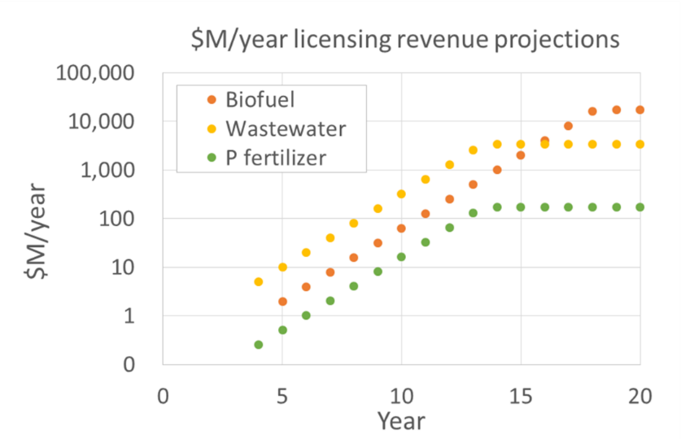

**Figure 6. PIARCS’ projected partial revenues.** A possible outcome

**Section 3: Dividends, Risk, Valuation, Investment rounds and Corporate structure**

## **A – Proposed dividend returns structure**

The contractual dividend structure, provided as an amendment to PIARCS’ Certificate of Incorporation (COI), was designed to ensure investors high returns without hindering PIARCS’ primary focus of global market expansion. Below is a simplified and explicated version of the COI dividend structure. An example dividend accrual spreadsheet is provided in the Financial Projections, and the corresponding guidelines are provided in the Business Plan Appendix.

### Some key definitions

“**ANI**” means Annual Net Income calculated in accordance with generally accepted accounting principles (U.S.)

“**Capital Return Date**” means the last day of the fiscal year in which all of the Preferred Holders have accrued (whether or not paid) dividends in an amount equal to their initial investment.

“**Common Holder**” means each holder of a share of Common Stock.

“**Common Stock**” has the meaning set forth below (Section 3 A-c)

“**Dividend**” or “**Div**” means yearly Dividend.

“**div_TSC**” means the aggregate number of dividend-accruing shares of Common Stock issued and outstanding at the end of each fiscal year. Div_TSC ranges from 0 to TSC, once all Common Stocks have become dividend-accruing stocks, subject to significant income of the corporation (see Section 3 A-b below).

“**Floating** **Threshold**” or “**FT**” means the product of Original Value multiplied by TSF. The floating threshold value ranges from $0.5M at Year 1 to $2.5M once all Common Stocks have become dividend-accruing stocks (see Section 3 A-c below).

“**Original Value**” shall mean $25 per share of Series A Preferred Stock.

“**Preferred Holder**” means each holder of a share of Series A Preferred Stock.

“**Series A Preferred Stock**” has the meaning set forth below (Section 3 A-b)

“**TSC**” means the aggregate number of shares of Common Stock issued and outstanding at the end of each fiscal year

“**TSP**” means the aggregate number of shares of Series A Preferred Stock issued and outstanding at the end of each fiscal year.

“**TSF**” means the aggregate number of shares of Series A Preferred Stock issued and outstanding at the end of each fiscal year (or **TSP**) added to the aggregate number of shares of dividend-accruing Common Stock issued and outstanding at the end of each fiscal year (or **div_TSC**). Such that TSF = TSP + div_TSC.

### Dividends on Series A Preferred Stock

Preferred Holders shall be entitled to receive, and the Corporation shall pay out of funds legally available therefor, cumulative preferred dividends in an amount per share equal to the Dividend/TSF, payable in cash:

* Beginning on the third anniversary of the Original Issue Date and ending on the “Capital Return Date”, the Dividend is equal to 25% of the Corporation’s ANI.
* Beginning on the first day of the fiscal year following the Capital Return Date and in each fiscal year thereafter, (A) if ANI for such fiscal year is no more than four times the Floating Threshold, the Dividend is equal to 20% *ANI and (B) if ANI for such fiscal year is greater than four times the Floating Threshold, the Dividend is equal to Floating Threshold + 2.5%(ANI - 4*Threshold Amount), but in any event no more than 1000% of the Floating Threshold.

In more mathematical terms

Phase 1:

When: 3rd anniversary => Capital Return Date

**Dividend** = 25% ANI

Dividends per preferred share = 25% ANI /TSF

Dividends per common share = 0

Phase 2:

When: Capital return date => for ever

And: ANI < 4* Floating Threshold

**Dividend** = 20% ANI

Dividends per preferred share = 20% ANI / TSF

Dividends per common share = 20% ANI /TSF * div_TSC / TSC

Phase 3:

When: Capital return date => for ever

And: ANI > 4* Floating Threshold

And: Dividend < 10 * Floating Threshold

**Dividend** = Floating Threshold *(100% + 10%(ANI-4* Floating Threshold)/4* Floating Threshold))

**⬄** **Dividend =** Floating Threshold + 2.5%(ANI-4* Floating Threshold)

**⬄** **Dividend** = 90% Floating Threshold + 2.5% ANI

As long as **Dividend** < 10 * Floating Threshold

Otherwise **Dividend** = 10 * Floating Threshold

Rationale for this complicated set of mathematical conditions

1. The ratio Dividend/ANI is <25%, such that the Dividend is at most 25% of the ANI in early phase 3.
2. The ratio Dividend/ANI decreases as ANI increases
3. The Dividend increases as ANI increases

Hence, we “have our cake and eat it too”: the financial burden of the Dividends lightens as the company grows (ii), while the Investors still see a steady increase in Dividends (iii) – which is capped by a yearly dividend return of 10 times the initial investment amount. That is: an investor investing $100,000 will be earning at most $1,000,000 *yearly* in dividends when the company is making significant revenues. Importantly, the Dividends can always be paid since they are only a fraction of the ANI (i). Proofs for i, ii and iii are provided below.

This complicated math also allows the Preferred Holders, which hold an aggregate of 20% of the company in terms of stock (for a $800,000 seed investment), to be treated as sole/majority shareholders with respect to dividend accruals in the early phase of the corporation. Indeed, Common Stock only start accruing dividends on par with Preferred Stocks subject to the condition of significant income.

Mathematical proofs

1. The ratio Dividend/ANI is <25%, such that the Dividend is at most 25% of the ANI in early phase 3.

In Phase 3, ANI>4*FT and Div = 0.9*FT + 0.1/4*ANI

* 1/4 > FT/ANI
* 0.9/4 > 0.9* FT/ANI
* 0.9/4 + 0.1/4 > 0.9* FT/ANI + 0.1/4
* 1/4 > Div/ANI ■

In Phase 4, ANI>4*FT and 0.9*FT + 0.1/4*ANI > Div

* 1/4 > FT/ANI
* 0.9/4 > 0.9* FT/ANI
* 0.9/4 + 0.1/4 > 0.9* FT/ANI + 0.1/4 > Div/ANI
* 1/4 > Div/ANI ■

1. The ratio Dividend/ANI decreases as ANI increases

In Phase 3, ANI>4*FT and Div = 0.9*FT + 0.1/4*ANI

* Div/ANI = 0.9*FT/ANI + 0.1/4
* Div/ANI decreases as ANI increases ■

In Phase 4, ANI>4*FT and Div = 10*FT

* Div/ANI = 10*FT/ANI
* Div/ANI decreases as ANI increases ■

1. The Dividend increases as ANI increases

In Phase 3, ANI>4*FT and Div = 0.9*FT + 0.1/4*ANI ■

### Dividends on Common Stocks: a slow and conditional accrual of dividends

Common Holders shall be entitled to receive, and the Corporation shall pay out of funds legally available therefor, cumulative dividends at the rate per share equal to the Dividend/TSF*div_TSC/TSC, payable in cash:

Beginning on the third anniversary of the Original Issue Date:

* for fiscal years where ANI is at least 1 time, but less than 4 times the Floating Threshold of the previous year, div_TSC will increase by adding 2%*(TSP+TSC), as of the last day of such fiscal year to div_TSC as of the last day of the prior fiscal year (pro-rated for the first fiscal year based on the number of days from the third anniversary of the Original Issue Date until the end of such fiscal year); and
* for fiscal years where ANI is greater than or equal to 4 times the Floating Threshold of the previous year, div_TSC will increase by adding 8%*(TSP+TSC), as of the last day of such fiscal year to div_TSC as of the last day of the prior fiscal year.

In either case, until TSP+TSC = TSF (at which point, no further increases to div_TSC will be made).

In more mathematical terms

When: Capital return date => for ever

And: 1* FT(year n-1) < ANI < 4* FT(year n-1)

Div_TSC(year n) = Div_TSC(year n-1) + 2% (TSP + TSC)

Subject to Div_TSC(year n) ≤ TSC

In other words, subject to an ANI comprised between 1 time and 4 times the floating threshold of the previous year, the number of dividend-accruing common stocks on a given year is the number from the previous year plus 2% of the total number of stocks, as long as this number is lower than the total number of common stocks.

When: Capital return date => for ever

And: ANI ≥ 4* FT(year n-1)

Div_TSC(year n) = Div_TSC(year n-1) + 8% (TSP + TSC)

Subject to Div_TSC(year n) ≤ TSC

In other words, subject to an ANI greater than 4 times the floating threshold of the previous year, the number of dividend-accruing common stocks on a given year is the number from the previous year plus 8% of the total number of stocks, as long as this number is lower than the total number of common stocks.

### PIARCS’ dividend projections

As the Annual Net Income increases, dividends increase (**Fig. 7**) while financial burden decreases (**Fig. 8**). By Year 6, 4X projected ROI from dividends only; by Year 11, 29X ROI; by Year 16, 79X ROI.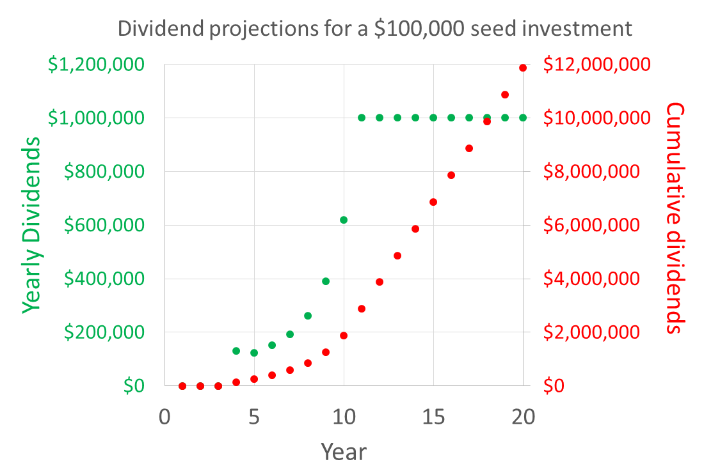

**Figure 7. Proposed dividends based on projected partial income**

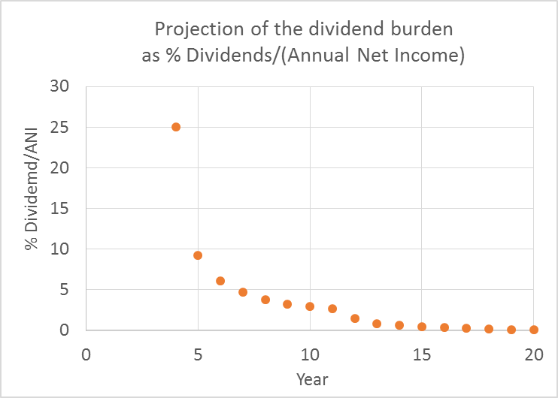

**Figure 8. Projected financial burden of the dividends**

**B – Risks and mitigating factors**

|  |  |  |
| --- | --- | --- |
| Area | Risk of failure | Comment |
| Competition | Very Low | IP approaches are novel in both areas  Cooperative strategy for expansion |
| Regulatory | Very Low | Thanks to PIARCS’ sustainability focus; effort to lead and broadly enable environmental regulation compliance |
| Operations (Phosphorus) | Very Low | Founder’s experience in bacterial physiology |
| Operations (Algae) | Medium | Founder has a well-established action plan which relies on contractors to carry-out specific aspects of the project |
| Technical (Phosphorous) | Medium | Inherent behavior of systemª |
| Technical (Algae) | High | Inherent behavior of systemª |
| Funding needs | Medium | Intermediate funding needs to validate two key scientific breakthroughs |
| IP time constraints | High | Constraint to raise investments to obtain indoor prototype validations in-time for filing patents |

**Table 5. Risks and Mitigating factors.** ªThe risks associated with the inherent behavior of the system are discussed below (Section 3-C).

**C – Risk mitigation in terms of probabilities**

For PIARCS to succeed financially and ensure investors’ return, only one of the independent technologies (either Algae or Phosphorus) needs to work.

Since the two technologies are independent, the probability for the success of both is the product of the individual probabilities of success (see **Fig. 9**).

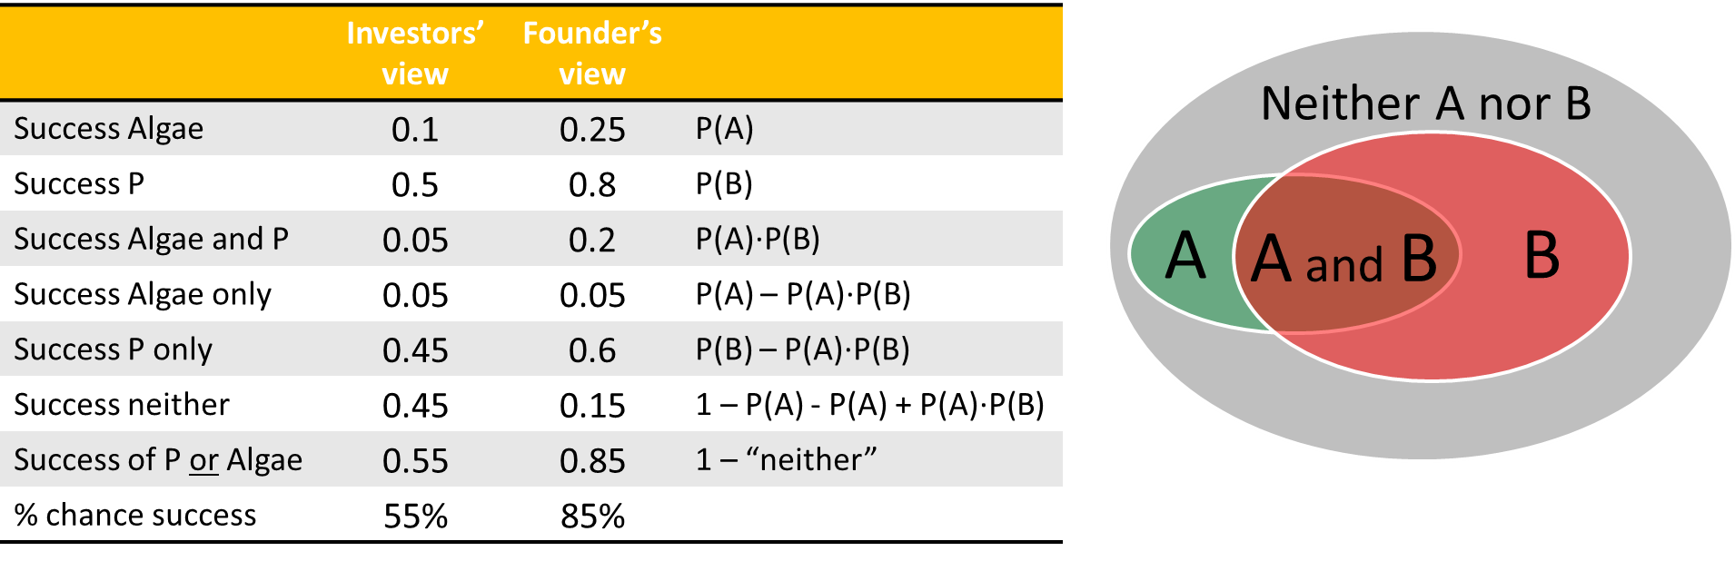

**Figure 9. Risk mitigation for the investors in terms of probabilities**

From the investors’ perspective, in the area of algal biofuel, the numerous failures of Algae Biofuel ventures to deliver milestones warrant a 10% chance of success. In the founder’s view, in the light of her extensive experimental and theoretical work, the chances of scalable implementation are on the order of 25%.

From the data presented in the area of phosphorus removal and accumulation, the investors may give the technology a 50% chance of success. In the founder’s view, in the light of her extensive work and her exposure to the field of P removal from wastewater, the chances of scalable implementation are on the order of 80%.

Noting that, in the first 15 years, wastewater treatment license revenues dominate PIARCS’ income, risk will be skewed favorably toward successful P technologies.

Therefore, while PIARCS has a 5-20% chance of success for both Algae and P technologies implementation, it has a 55-85% chance of ensuring investors’ returns via the success of either technology.

**D – Valuation (seed funding stage)**

The valuation calculations are provided in the Excel file “Financial projections” in the “Valuation” worksheet.

The exit value calculation of $125M was based on a $12.5M gross annual income by Year 5, at which point both technologies have been validated, and an Exit = 10 times the gross income. This 10X value is in agreement with the enormous market potential at Year 5.

|  |  |  |
| --- | --- | --- |
| Scorecard Method | $2,250,000 | Table 7 |
| Risk Factor Adjusted Method | $2,667,168 | Table 8 |
| Net Present Value Method | $3,125,000 | Table 9 |
| Burn Rate Method | $3,000,000 | Table 10 |
|  |  |  |
| Average | **$2,760,542** |  |
| Standard Deviation | $391,383 |  |
| Median | $2,833,584 |  |

**Table 6. Four valuation methods (post-money valuation).** A value of $2.5M post-money valuation will be used subsequently to raise the 20% seed Equity. The table for each method is shown below (Tables 7-10).



**Table 7. Scorecard method**



**Table 8. Risk adjusted method**



**Table 9. Simplified Net Present Value method**



**Table 10. Burn-rate method**

**E – Planned investment rounds**

The seed round fits into the broader scope of several investment rounds (Fig. 10).

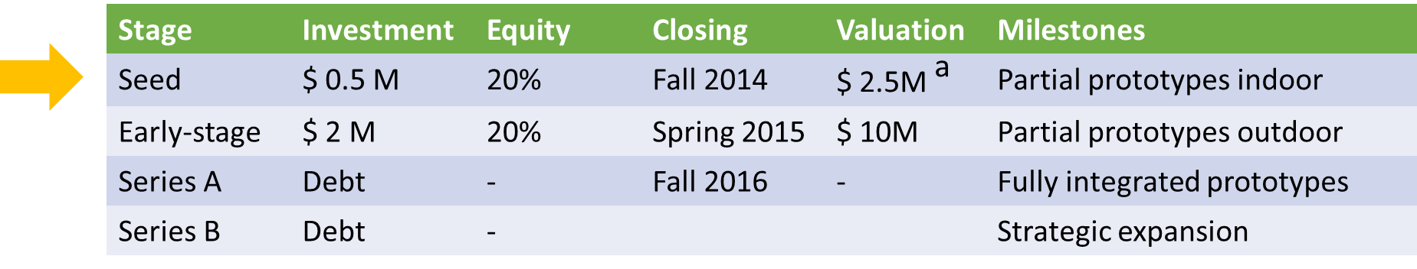**Figure 10. Planned rounds of investment.** aBased on a valuation of $ 2.8 ± 0.4 M (Section 3-D).

Various VC firms have shown interest in PIARCS’ technology (Aster Capital, Pangea Ventures, Emerald Technology Ventures). These firms require prototype validation before they can commit their investors’ funds – which is the object of the seed-stage funding round and milestones. VC’s will be contacted again for the early-stage funding.

Regarding the subsequent rounds, Debt financing will be preferred over Equity, in order to avoid stock dilution. Debt financing is most appropriate due to the fact that licensing contracts with wastewater facilities would ensure PIARCS a reliable income.

In addition, strategic partnerships will be sought as a means to fund R&D and large-scale prototype implementation. In parallel, PIARCS will apply for research and infrastructure grants (BDEG Program…).

**F – PIARCS’ corporate structure and taxation**

PIARCS is currently a Delaware Public Benefit Corporation and is taxed as a C-corp. The dividend structure incurs unnecessary financial burden, since the Annual Net Income (ANI) is taxed at the corporate level. Therefore, depending on the funding route, PIARCS may choose to become a B-lab certified B corporation and become a LLC. Indeed, the LLC is a flow-through entity, such that the ANI is not taxed. This shift would highly benefit the shareholders by increasing the dividend returns. The B-lab certification would maintain the idea of the Public Benefit purpose.

**Section 4: Appendix and Supporting Documents**

**A – PIARCS’ founder CV**

CV provided below.

**B – PIARCS’ legal and official documents available upon request**

PIARCS’ RoC Due Diligence Repository provides the following collated documents:

* Certificate of Incorporation of PIARCS, PBC, as a Delaware Public Benefit Corporation (filed March 10 2014)
* Action of Incorporator of PIARCS, PBC pursuant to Section 108 of the Delaware General Corporation Law with respect to the initial organization of the corporation (March 12, 2014)
* PIARCS, PBC Action by unanimous written consent of the Board of Directors (March 12, 2014)
* Bylaws of PIARCS, PBC (March 12, 2014)
* PIARCS, PBC indemnification agreement (March 12, 2014)
* PIARCS, PBC stock purchase agreement (March 12, 2014)
* PIARCS, PBC action by unanimous written consent of the board of directors in accordance with Section 141 (f) of the Delaware General Corporation Law (March 12, 2014)
* Amendment of the Certificate of Incorporation of PIARCS, PBC, as a Delaware Public Benefit Corporation (filed August 20 2014)
* Joint Written Consent for the issuance of additional stocks (August 20 2014)
* Amendment of the Certificate of Incorporation of PIARCS, PBC, as a Delaware Public Benefit Corporation (filed August 20 2014)

The following documents are available upon request:

* PIARCS, PBC IRS Form SS-4, Federal Employer Identification Number (March 25, 2014)
* PIARCS, PBC non-disclosure agreement
* PIARCS, PBC independent contractor services agreement
* Colorado State Statement of Foreign Entity Authority – to conduct business in the state of Colorado (filed August 19 2014)
* Lease for the lab-space at the University of Colorado Biofrontiers building (lease start date: August 15, 2014)
* First invoice for the lab-space lease (August-September 2014)

**C – Guidelines to implement dividend projections**

The following guidelines are provided to explicate the implementation of the COI dividend function to the provided Financial Projections (Excel spreadsheet): see the “RoC PIARCS financial projections & use of funds.xls”, worksheet “Financial Projections”.

Using the 20% for $M 0.5 as a reference, with the use of the number of shares.

1. Determination of the market size from licensing prices
2. Arbitrary determination of market share, with a yearly doubling of the share. Note that the dynamics will likely differ, but this ‘doubling’ allows to detail the various phases of dividends.
3. Arbitrary determination of the operating costs (minimal operating costs to support essential R&D, tech support and marketing activity)
4. The above elements determine the ANI (annual net income) for the corporation
5. The initial Floating Threshold from cells L14, L15 is defined as:

$2.5M * TSPA / total#shares

Cells input: =R$1*(P$3)/P$5

Note that the $2.5M in R$1 value is an arbitrary value to reflect market expansion dynamics.

The initial % shares accruing dividends cells N14, N15 is:

=100*(P$3)/P$5

Where P$5 is the total number of shares, P$3 is the number of series A Preferred shares.

1. The % of dividend-accruing shares needs to be calculated using the Floating Threshold from the previous year, otherwise there is a circular reference. Cells L14 and L15, the floating threshold is equal to the initial investment.
2. Cell M16 input K16/L15 to determine the (ANI current year)/(FT of previous year).
3. Cell N16 input before nesting the max 100% rule

IF(AND(R15>1,M16>=4),N15+8,IF(AND(R15>1,M16<4,M16>=1),N15+2,N15+0))

R15>1 ensures the capital return date at the previous year

N15: dividend-accruing shares from the previous year

Cell N16 input AFTER nesting the max 100% rule:

= MIN(100, clause above), that is:

Final N16 input:

=MIN(100,IF(AND(R15>1,M16>=4),N15+8,IF(AND(R15>1,M16<4,M16>=1),N15+2,N15+0)))

Depending on the value of the ANI/(FT previous year), the dividend-accruing stocks are increased by 0%, 2% or 8%.

1. Rules for the dividend accrual are met in the cell P16

Cell P16 input (total dividend in $M per year) before nesting the max dividend as 10*FT rule

=IF(AND(R15>1,M16>=O16),0.9*L16+0.025*K16,IF((AND(R15>1,M16<4)),0.2*K16,0.25*K16))

R15>1 ensures the capital return date at the previous year

Cell P16 input AFTER nesting the max dividend as 10*FT rule:

=MIN(10*L16, above statement)

Final P16 input:

=MIN(10*L16,IF(AND(R15>1,M16>=O16),0.9*L16+0.025*K16,IF((AND(R15>1,M16<4)),0.2*K16,0.25*K16)))

1. Q16 input =P16/L16
2. R16 input =SUM(Q$14:Q16) which is the cumulative dividend/initial investment
3. Drag LMNOPQR from row 16 down to infinity
4. In this example, the cell R33 shows that the cumulative return would be about 119X the initial investment at the 20 year mark, depending on the initial investment.

**D – TERM SHEET (modified September 23rd 2014)**

Patricia Rogers at Moye White wrote the Material Terms of Offering as well as the Subscription Agreement. Revisions as of September 25th 2014 will feature the following modifications, which will be final once negotiated with the investors.

September 23rd, 2014

**Re: Proposed Equity Issuance of PIARCS, PBC**

The following provides an overview of a proposed equity sale (the “Transaction”) between PIARCS, PBC, a Delaware public benefit corporation, (“Issuer”) and certain investors to be determined (each an “Investor” and collectively, the “Investors” and, together with the Issuer, each a “Party” and collectively the “Parties”). This summary does not constitute an offer of securities and any transactions contemplated by this summary are subject to the execution of definitive agreements with respect to the Transaction, compliance with all applicable federal and state securities laws and regulations and compliance with the other terms and conditions of the Transaction provided in this summary or in the definitive agreements for the Transaction.

**Issuer** PIARCS, PBC, a Delaware public benefit corporation

**Transaction** Issuance and sale of up to 20,000 shares of Issuer’s existing Series A Preferred Stock (the “Shares”), $0.001 par value, at a price per share equal to $25.00, for an aggregate purchase price of $500,000.

**Purpose** To fund working capital needs of the Issuer.

**Subscription**

**Agreement** Investors will each enter into a subscription agreement with Issuer in a in the form attached hereto as Exhibit B (the “Subscription Agreement”).

**Shareholders**

**Agreement** Each Investor will execute a Joinder to the Issuer’s Shareholders Agreement, a copy of which is attached hereto as Exhibit C.

**Closing Date** On or before October 31st, 2014, with one or more subsequent closings on identical terms and conditions within sixty (60) days of the initial closing.

**Material Terms** Certain material terms applicable to the Series A Preferred Stock are listed on Exhibit A hereto. Investors are encouraged to review the Subscription Agreement, Shareholders Agreement, and the Issuer’s Certificate of Incorporation, a copy of which is attached hereto as Exhibit D, with their respective accountants, legal counsel and investment advisors prior to making any investments in Issuer.

EXHIBIT A

Summary of Material Terms Applicable to Series A Preferred Stock

The following is not meant to be comprehensive, and Investors are encouraged to review the Issuer’s Certificate of Incorporation, Subscription Agreement and Shareholders Agreement thoroughly before making any investment in the Issuer.

|  |  |
| --- | --- |
| **Topic** | **Summary of Terms** |
| Minimum Investment | The minimum investment in this Transaction is $25,000.00 (1,000 shares of Series A Preferred Stock (“Preferred Stock”)) |
| Dividends | Preferred Stock will accrue dividends as set forth in the Issuer’s Certificate of Incorporation (“COI”), which will be payable as set forth in the COI. |
| Voting Rights | Holders of Preferred Stock are entitled to one vote per share of Preferred Stock, voting together with the holders of the Issuer’s common stock, $0.001 par value (the “Common Stock”) on all matters that come before the shareholders. |
| Board of Directors | The Issuer’s Board of Directors is currently set at one (1) director, and Alexandra Holland, the Issuer’s Chief Executive Officer, is currently the sole director. The Issuer currently has no plans to increase the size of the Board of Directors, although the size of the Board of Directors may be increased at any time upon requisite vote of the shareholders. |
| Majority Shareholder | Alexandra Holland is the current sole shareholder of the Issuer, holding 80,000 shares of Common Stock and will continue to own a majority of the Issuer’s shares of capital stock following the closing of the Transaction. |
| Transferability | There is no public market for the Common Stock or Preferred Stock, and the shares are subject to restrictions on transfer as set forth in the Shareholders Agreement. |
| Right of First Refusal | Potential sales of Common Stock and Preferred Stock are subject to a right of first refusal in favor of the Issuer and the other shareholders, as set forth in the Shareholders Agreement. |
| Mandatory Sale | If the holders of a majority of the outstanding shares of Common Stock and Preferred Stock approve certain change of control transactions with an independent third party, all other shareholders are required to consent to vote all of their shares of voting securities in favor of such transaction (including waiving appraisal or other rights they may have), as more fully set forth in the Shareholders Agreement. |
| Entity Conversion | The Issuer may, for tax purposes, elect to the convert the Issuer from its current corporate form into a limited liability company, upon the terms set forth in the Shareholders Agreement. By executing the Shareholders Agreement, Investors agree to such a conversion. |
| Non-Solicitation | The Shareholders Agreement contains a covenant, applicable to all shareholders, not to solicit customers or employees of the Issuer, among other parties, so long as such shareholder is a shareholder of the Issuer, and for a period of one (1) year thereafter. |
| Confidentiality | All shareholders are required to maintain the confidentiality of the Company’s Proprietary Information (as defined in the Shareholders Agreement), so long as they are a shareholder of the Issuer and for a period of five (5) years thereafter. |
| Issuances of Additional Stock | The Issuer’s Board of Directors may, at any time, authorize additional issuances of its capital stock with rights and preferences that are senior to the Common Stock and Preferred Stock. No shareholder has any preemptive or anti-dilution rights with respect to such issuances. |

**Seed-stage valuation**



Where “Preferred Stocks” are “Series A Preferred Stocks”

**Dividend structure**

Please refer to the Section 3A of the business plan.

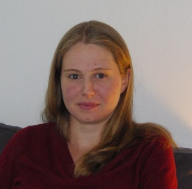Alexandra D. Holland, PhD

PIARCS, PBC founder and CEO

3190 29th Street

Boulder, CO 80310

holland@piarcs.org

(562) 310-7570

**Education**

PhD in Chemical Engineering University of Washington, WA, USA 2001-2007

BS Chemical Engineering with Honors UC Berkeley, CA, USA 1997-2001

Baccalauréat Scientifique (France) Lycée Henri IV, Paris, France 1995

**Honors and Fellowships**

Foundation Fourmentin Fellow with Prof. Danchin at the Institut Pasteur (Paris) 2009

NSF International IGERT Fellow at the U. of Washington 2006-2007

“Multinational Collaboration on Challenges to the Environment”

NSF GRFP (Graduate Research Fellowship Program) Fellow at the U. of Washington 2002-2005

Achievement Reward for Research Scientist Fellow at the U. of Washington 2001-2004

UC Berkeley President's Undergraduate Fellowship (funding for independent research) 2000-2001

American Institute of Chemical Engineers UC Berkeley Outstanding Senior Award 2001

Dow Chemical UC Berkeley Outstanding Junior Award 2000

**Research Experience**

**Post-Doctorate research**

Post-doctorate fellowship, Institut Pasteur, Paris Oct 2011- 2013

Supervised by Spencer Shorte, director of the Imagopole

Development of a mathematical description for the Fluorescence by Unbound Excitation from Luminescence (FUEL, patent pending) phenomenon. Experimental validation of the model. Development of *in vitro* applications.

Post-doctorate fellowship at Purdue University, West Lafayette, IN Feb - Jun 2011

Supervised by Barry Wanner, Professor, Dept. of Biological Sciences

Fermenter setup for comparative transcriptional profiling (RNA-Seq) of *E. coli* mutants under phosphate limitation. Polyphosphate metabolism.

Visiting scientist at Brigham Young University, Provo, UT Oct 09 - Dec 2010

Supervised by W. McCleary, Associate Professor, Microbiol. & Molecular Biology

Regulatory interactions between phosphate and polyphosphate metabolisms.

Post-doctorate fellowship, Institut Pasteur, Paris Feb-May 2009

Supervised by A. Danchin, director of the Genomes and Genetics Department

Enzymatic polyphosphate assay and protein purification.

Visiting scientist at the University of Washington, Seattle, WA Aug-Dec 2008

Supervised by Mary Lidstrom, Professor of Microbiology and of Chemical Engineering, University of Washington Vice Provost for Research

Further work on polyphosphate metabolism to refine doctorate hypotheses.

**Doctorate research at the University of Washington (Seattle, WA)**

Thesis supervised by Mary Lidstrom (Microbiology and Chemical Engineering): 2001-2007

NSF IGERT Fellowship supervised by Tom Hinckley (College of Forest Resources): 2005-2007

**Undergraduate research at UC Berkeley (Berkeley, CA)**

Supervised by Jay Keasling, Professor, Chemical Engineering 2000-2001

Project mentored by Cynthia Gong and Neil Renninger

Cloning native promoters to engineer *D. radiodurans* for bioremediation.

Supervised by Jay Keasling, Professor, Chemical Engineering 1999-2000

Project mentored by Piper Trelstad and Trina McMahon

Polyphosphate assay in phosphorus-accumulating bacterial consortia.

Supervised by William Oswald, Professor, Civil and Environmental Engineering 1997-1998

Project mentored by Max Zarate and Tryg Lundquist

Influence of bacteria pre-treatment on the efficacy of the Algal-Bacterial Selenium Removal process.

**Publications**

* Holland AD, Rückerl F, Dragavon JM, Rekiki A, Tinevez J-Y, Tournebize R and SL Shorte. *In vitro* Characterization of Fluorescence by Unbound Excitation from Luminescence: Broadening the Scope of Energy Transfer. *Methods.*  **2014** 66(2): 353
* Holland AD and J Dragavon. Algal Reactor Design Based on Comprehensive Modeling of Light and Mixing. *Algal Biorefineries*, vol.1. Springer Publishing, New York, USA. (**October 15 2013**).
* Holland AD and D Wheeler. Methods for Estimating Intrinsic Autotrophic Biomass Yield and Productivity in Algae: Modeling Spectrum and Mixing-Rate Dependence. *Biotechnology Journal.* **2011** 6:584
* Holland AD, Dragavon J and DC Sigee. Methods for Estimating Intrinsic Autotrophic Biomass Yield and Productivity in Algae: Emphasis on Experimental Methods for Strain Selection. *Biotechnology Journal*. **2011** 6:572

**Others**

Programs: Mathcad, Clone Manager, Matlab

Languages: French (native), English, German (intermediate)

Citizenships: USA, France

Websites: <http://www.piarcs.org/>

<http://www.linkedin.com/in/alexandraholland>

Risk Factors; Disclaimer

**Not an Offer**. This Executive Summary is not an offer to sell or a solicitation of an offer to buy any security and may not be relied upon in connection with the purchase or sale of any security.

**Risk Factors; Disclaimer on Forward Looking Statements.** There are risks and uncertainties inherent in PIARCS' business plan, including the following:

* We require additional equity or debt financing to fund our business, including to fund general working capital and research and development activities.
* Efforts to protect our IP rights and to defend claims against us can increase our costs and will not always succeed; any failures could adversely affect profitability or restrict our ability to do business or to achieve projected licensing revenues.
* Others…..

The risks described above are not the only ones we face. Additional risks not identified here or that we currently do not know about may also impair our business, financial condition or results of operations. If we cannot address any of these risks and uncertainties effectively, or any other risks and difficulties that may arise in the future, our business, financial condition or results of operations could be materially and adversely affected.

This Executive Summary includes forward-looking statements that involve risks and uncertainties, including, among others, estimates and assumptions relating to market size, penetration rates, and IP licensing royalty rates. Such forward-looking statements are based on certain assumptions and expectations about strategies, objectives, goals, expectations, results, plans and projections of PIARCS, and the inclusion of projections should not be relied upon as a prediction of future events. These forward-looking statements are subject to risks and uncertainties, including those identified above, that could cause actual results, events, performance or financial conditions to differ materially from current expectations, projections and estimates.

**No Representation.** The date of this Business Plan is November 10th, 2014.  Neither PIARCS PBC nor any of its directors, officers, employees, representatives, has made or makes any representation or warranty, express or implied, to any person regarding the forward-looking statements and projections contained in this Executive Summary and none of them has nor assumes any intention or obligation to update or revise any forward-looking statements, whether as a result of new information, future events or otherwise. For the sake of clarity, only those limited representations and warranties that are made in final definitive written agreements regarding any transaction, when, as and if executed, and subject to the limitations, restrictions and disclosures as may be specified therein, will have any legal effect, and any term sheet, letter of intent or other form of preliminary agreement is not a definitive agreement.